Assignment (N+) Day-2(TCP/IP)
Task-1:
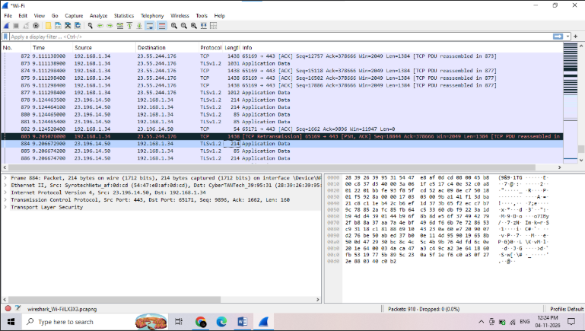
Network Access Layer: The line labeled "Ethernet II" in the middle section represents this layer, which shows the MAC addresses.
Internet Layer: The "Internet Protocol Version 4" line represents this layer, displaying the Source IP (23.196.14.50) and Destination IP (192.168.1.34).
Transport Layer: The "Transmission Control Protocol" line shows this layer, which contains the port numbers (443 and 65171).
Application Layer: The "Transport Layer Security" line at the very bottom represents the Application layer.
Task-2:
OSI Model Layer | TCP/IP Model Layer | App Example
7. Application | Application | WhatsApp UI
6. Presentation | Application | Instagram Encryption
5. Session | Application | Zoom Call
4. Transport | Transport | YouTube Stream
3. Network | Internet | Zomato Routing
2. Data Link | Network Access | Home Wi-Fi
1. Physical | Network Access | Ethernet Cable
Real-World Example Explanations:
- WhatsApp UI (Layer 7): The actual graphical interface where you type "Hello" and hit send.
- Instagram Encryption (Layer 6): Formats, compresses, and encrypts (via TLS) your photo uploads before transmission so they cannot be intercepted.
- Zoom Call (Layer 5): Opens, maintains, and cleanly closes the continuous two-way communication session between your laptop and Zoom's servers.
- YouTube Stream (Layer 4): Uses TCP or UDP to break down a large video file into smaller, manageable packets for smooth, sequenced delivery.
- Zomato Routing (Layer 3): Uses IP addressing to calculate the fastest logical path across the internet to send your order data to the restaurant's backend server.
- Home Wi-Fi (Layer 2): Uses MAC addresses to physically transfer data frames across your local network from your phone to your wireless router.
- Ethernet Cable (Layer 1): Converts the network data into raw electrical signals (or radio waves) of 1s and 0s to travel across the physical medium.

Task-3:
Source Port (443): Identifies the specific application or service sending the data, which indicates secure HTTPS web traffic in this case.
Destination Port (65171): Tells the receiving operating system which specific application (like your active browser tab) should receive this packet.
Sequence Number (9896): Numbers the data segments so the receiving device can accurately reassemble the full message in the correct original order.
Acknowledgment Number (1662): Confirms that previous data was successfully received and tells the sender the next sequence number the receiver expects to get.
Length (160): Indicates the total size of the TCP segment, ensuring the receiver knows exactly how much data to process.

Task-4:
Our Phone
⬇
Application Layer: You type a DM. The Instagram app encrypts the text and packages it as web data.
⬇
Transport Layer: Your phone splits the packaged message into smaller, numbered packets and adds port numbers so the pieces can be reassembled in the correct order.
⬇
Internet Layer: Your phone adds its own IP address as the sender and Instagram's server IP address as the destination to each packet so routers know exactly where to deliver them.
⬇
Network Access Layer: The packets are converted into raw Wi-Fi radio signals and sent to your home router using physical MAC addresses to begin their physical journey across the internet.
⬇
Instagram Server

Task-5:
The TLSv1.2 packet (Packet 884) from the Wireshark capture belongs to the Application layer of the TCP/IP model. This classification is identified by examining the bottom of the protocol stack in the packet details pane, which explicitly lists "Transport Layer Security" and carries a payload labeled "Application Data."
In a real-world scenario, because this traffic was captured while refreshing the Flipkart homepage, this packet represents the secure HTTPS transfer of actual website content. Specifically, it translates to your browser securely downloading encrypted product images, live item prices, or your personal shopping cart details from Flipkart's servers so the interface can render them safely on your screen.

